Task 5
Multimorbidity Prevalence Analysis

- How common is multimorbidity among lung cancer patients?
- Create a comorbidity count by combining hypertension, asthma, cirrhosis, and other cancer, then analyse its distribution.

Output

- Terminal Output
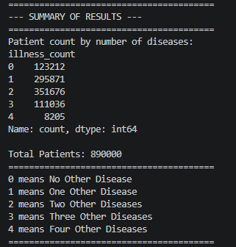
- Multimorbidity Count Graph
